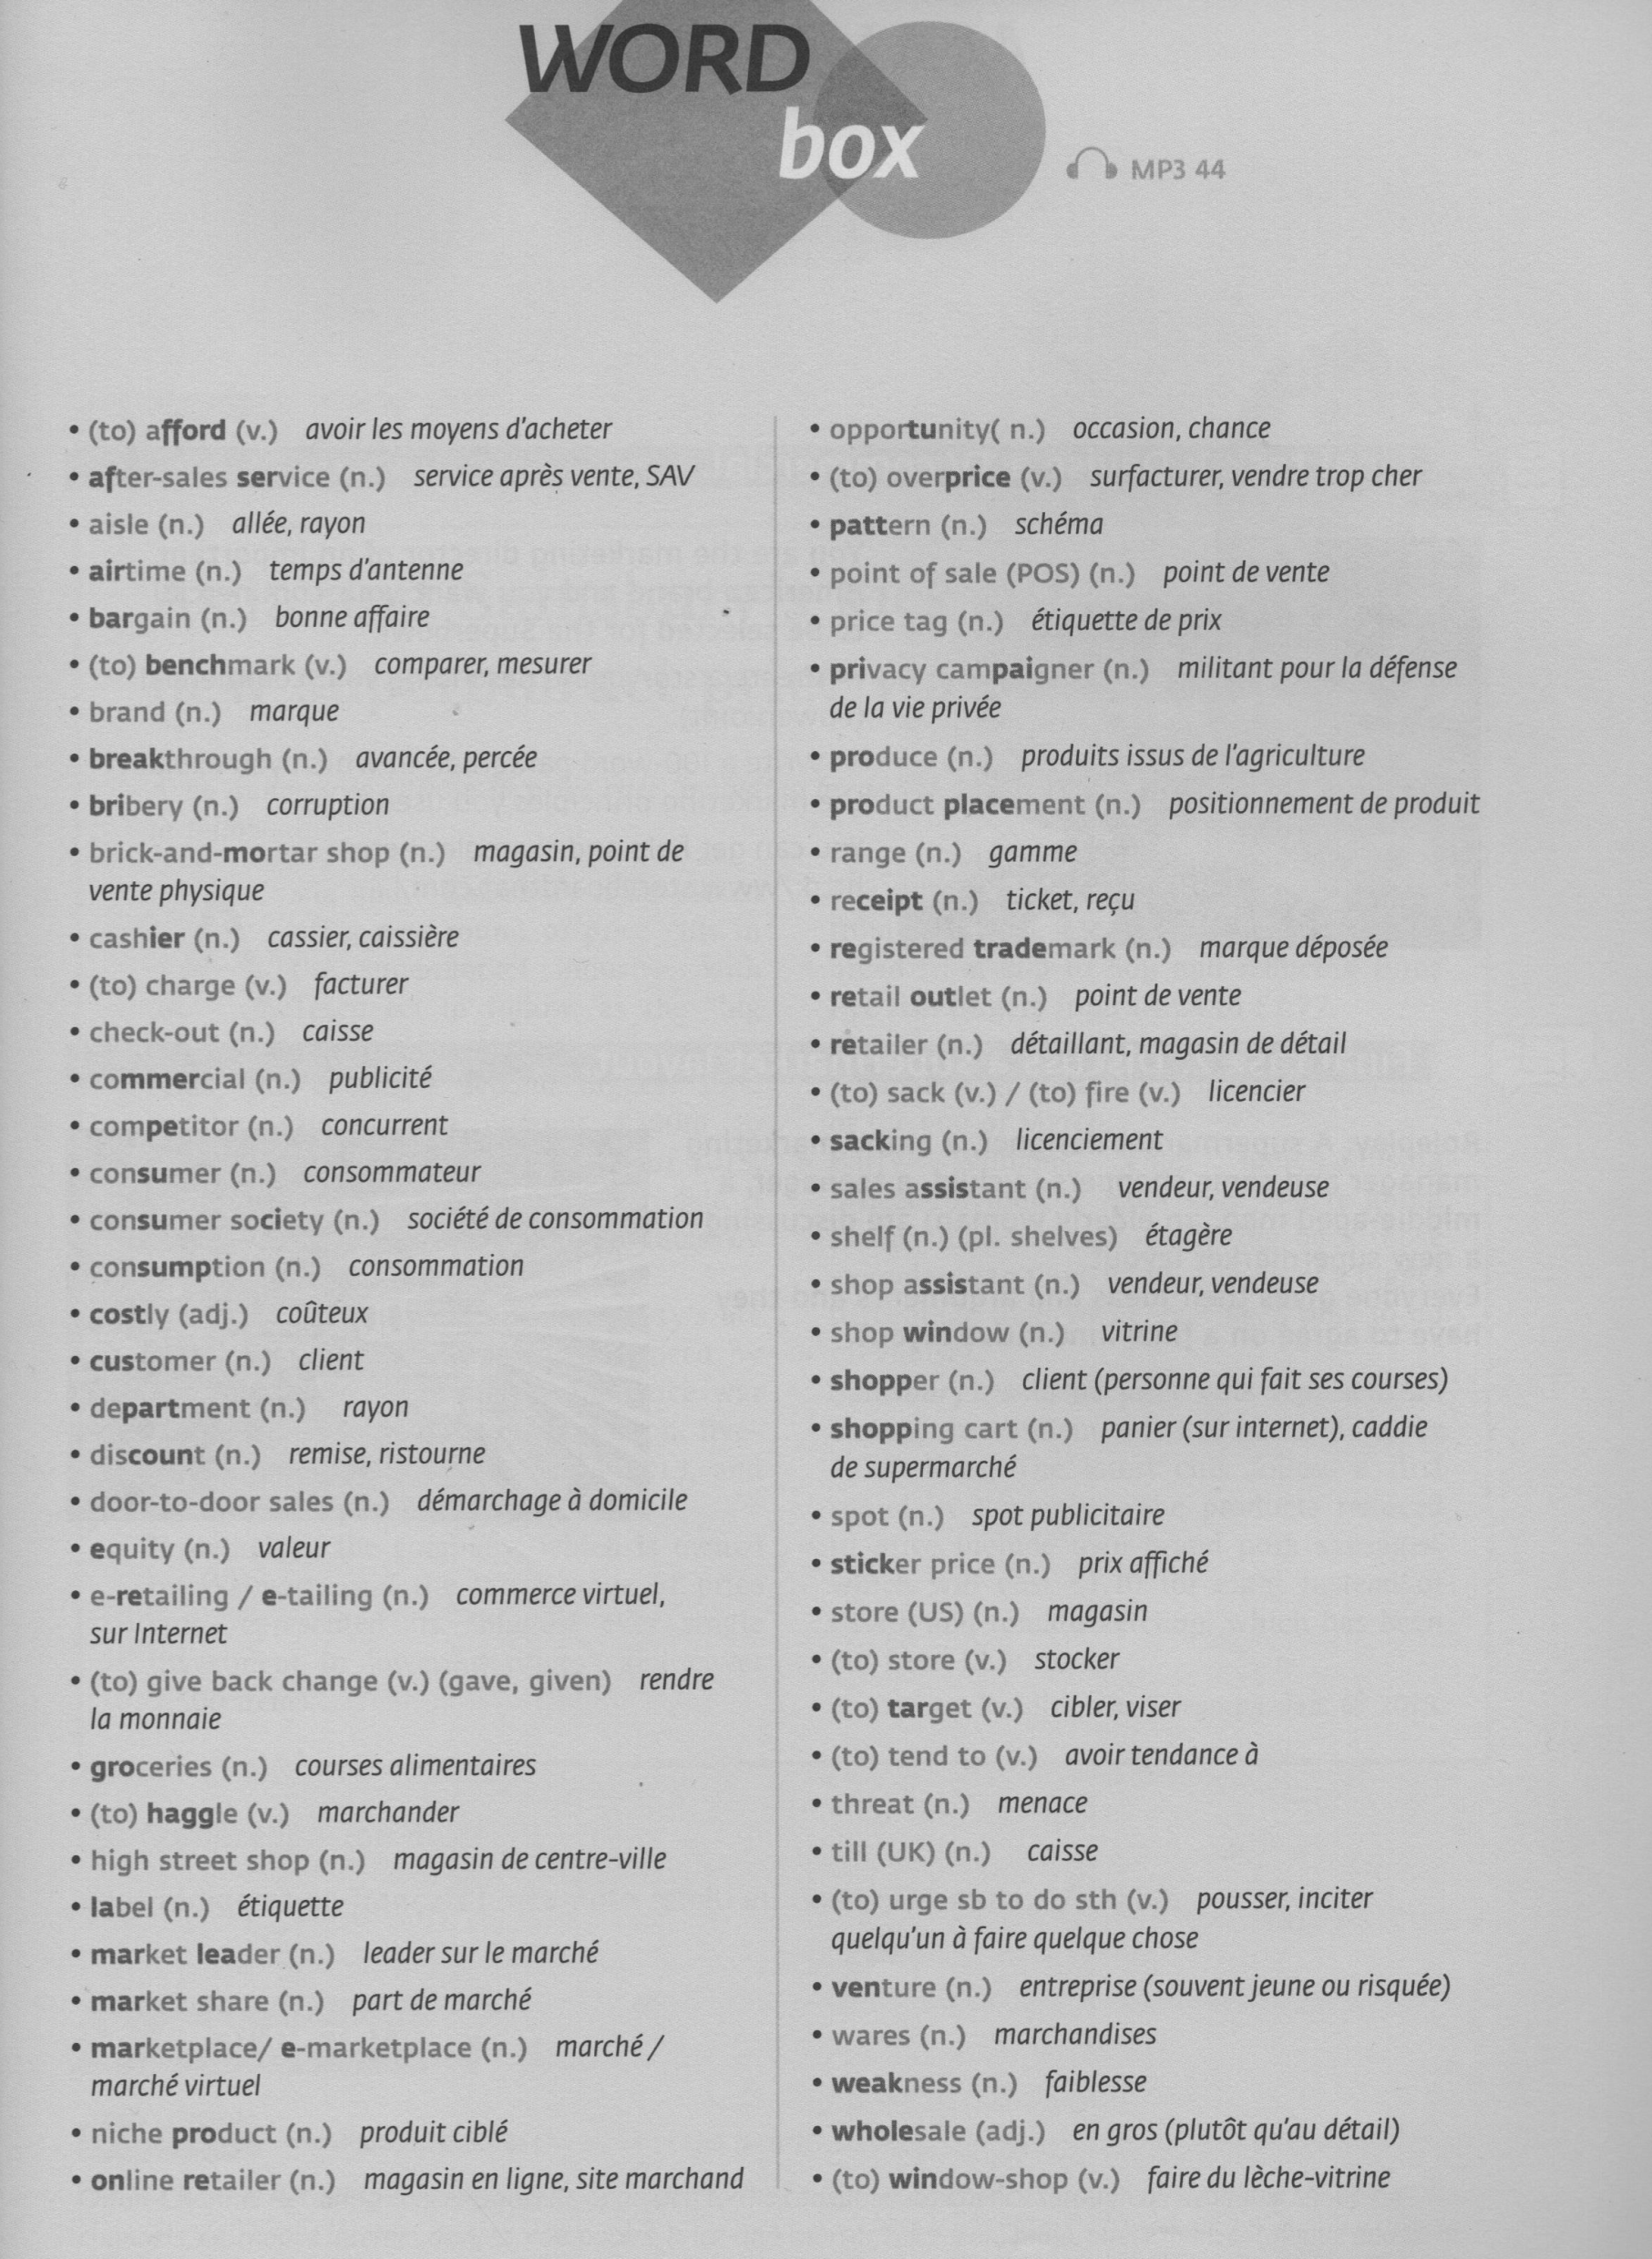

MARKETING, RETAILING & DISTRIBUTION

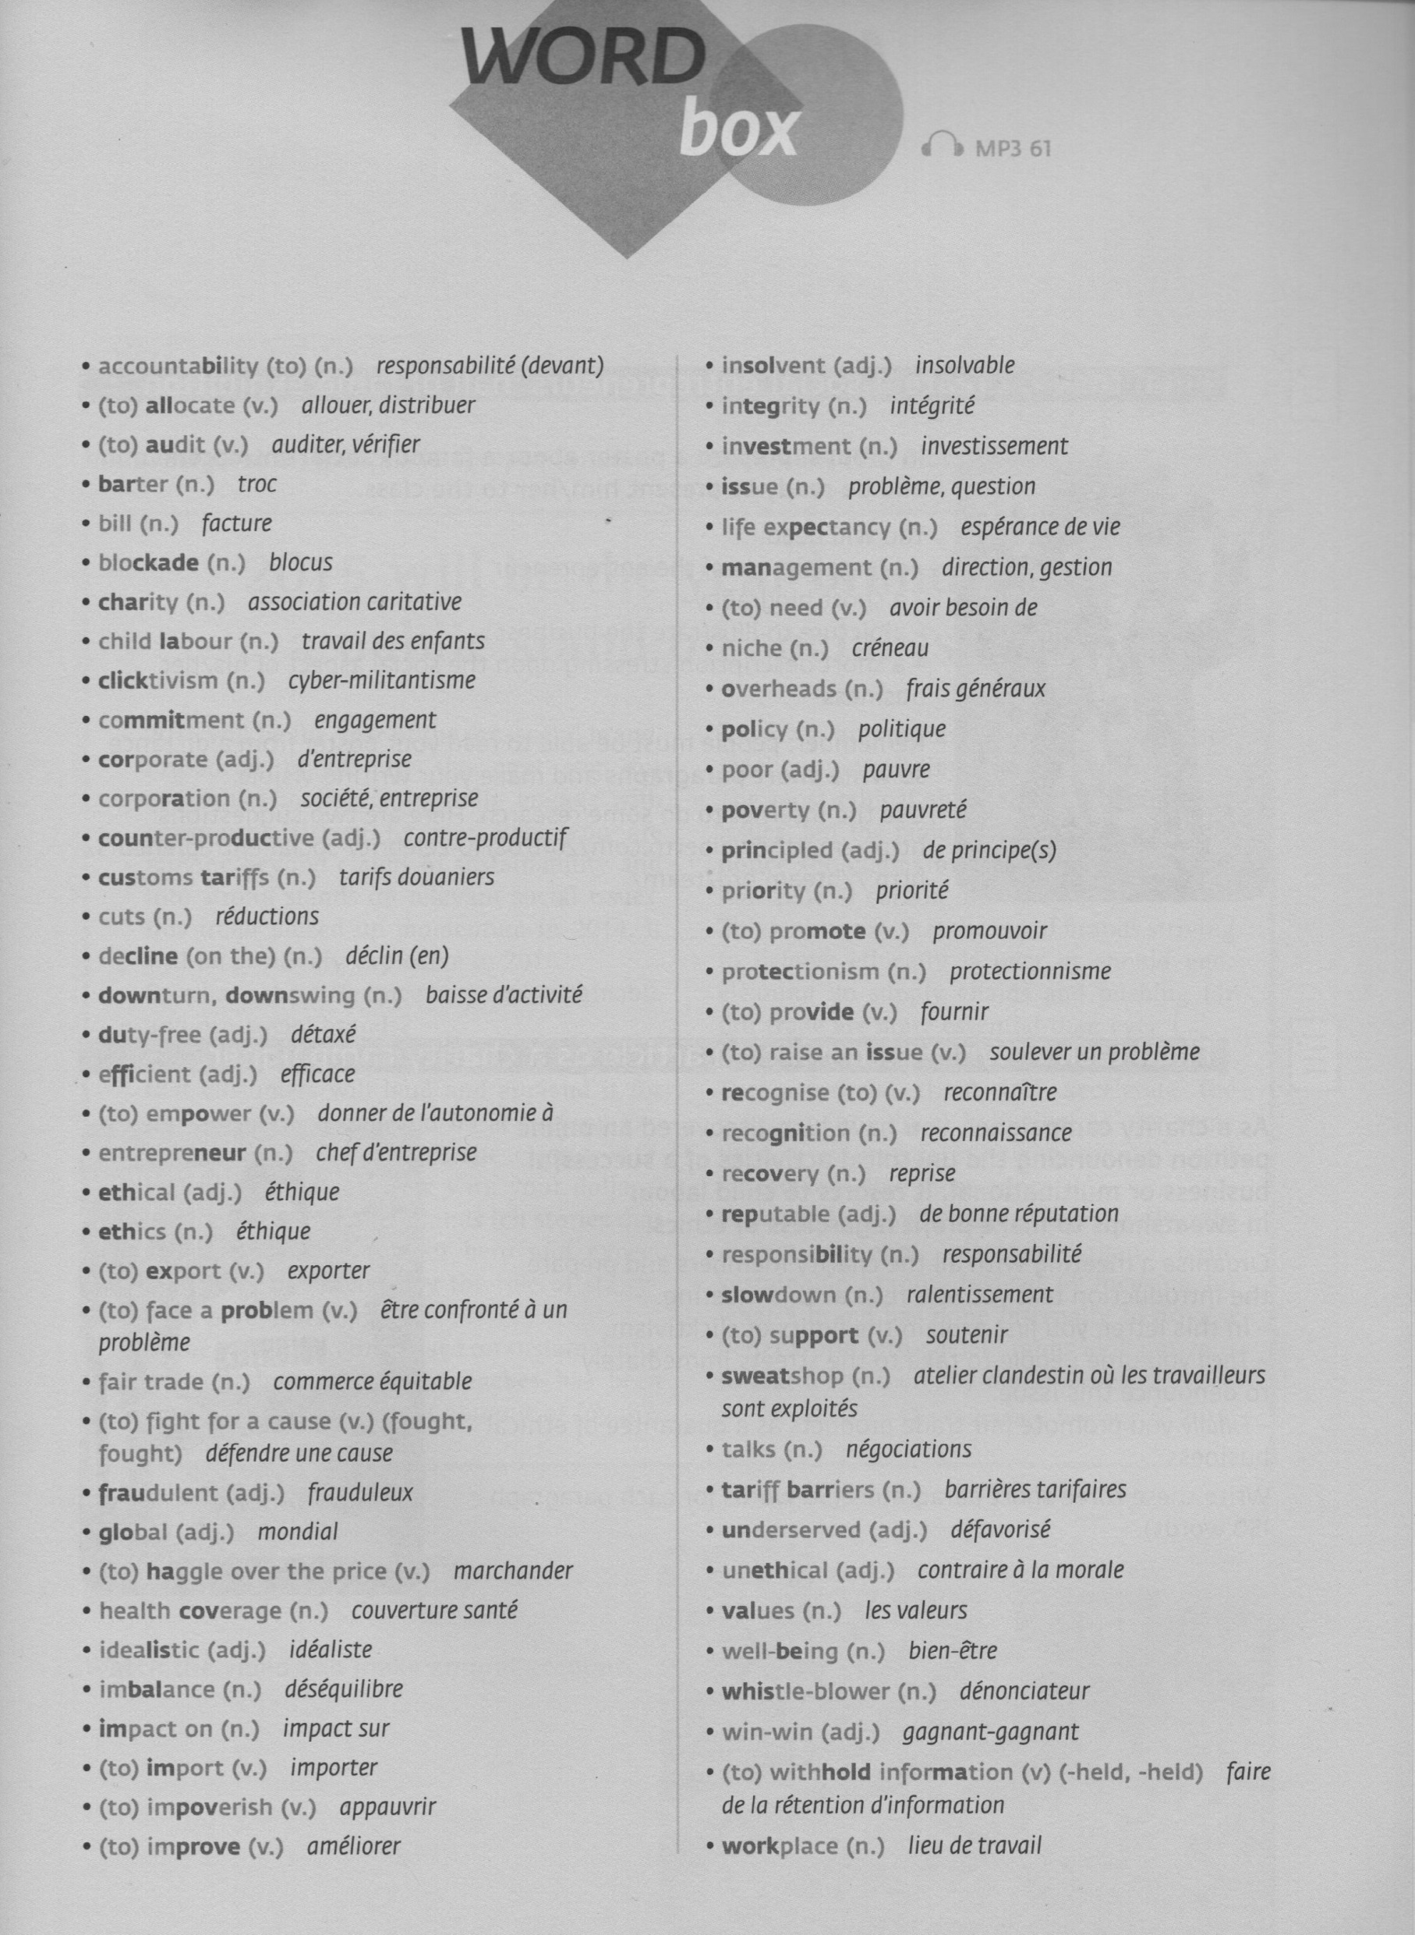

ECONOMICS & BUSINESS ETHICS